Project Development Phase
Model Performance Test
Date | 01 October 2026
Team ID | SWTID-2026-5228
Project Name | Import Data using Transform Maps (Spreadsheet)
Maximum Marks
Model Performance Testing:
Project team shall fill the following information in model performance testing template.
S.No. | Parameter | Values | Screenshot
1. | Model Summary | ServiceNow data import setup for employee data management using an Import Set (Employee Import, u_employee_import), a Transform Map (Sample Spreadsheet Import) and the Employee Test table (Employee ID, Employee Name, Email, Department, Location).  Field maps: u_employee_id, u_name, u_email, u_department and u_location are mapped to the matching Employee Test fields (5 of 5 fields mapped).  Note : If the Excel data matches the mapped fields, the records are created in the Employee Test table. Coalesce on Employee ID is used so that existing records are updated instead of duplicated. | 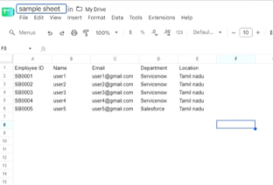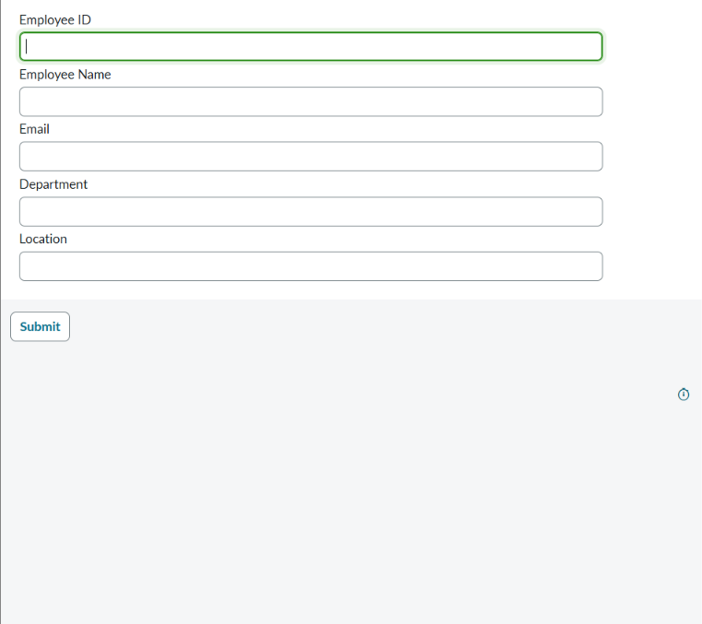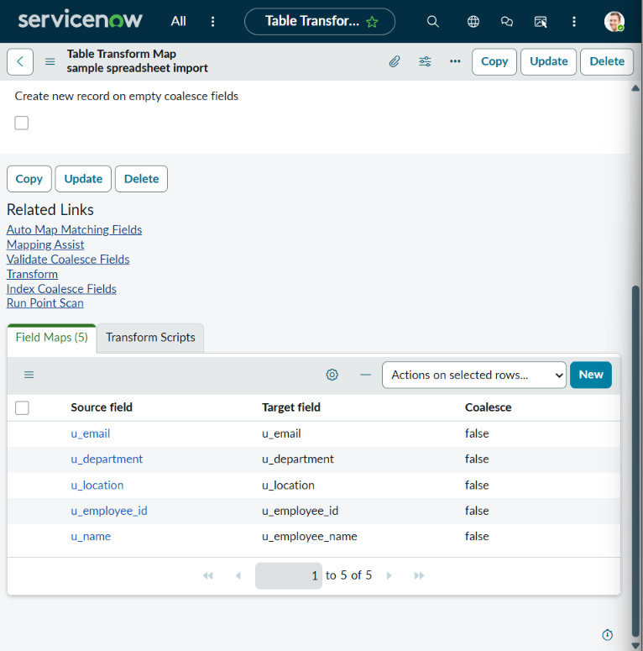
2. | Accuracy (Import Accuracy) | Load Data (ImportProcessor) - State: Complete, Completion code: Success  Processed: 5, Inserts: 5, Updates: 0, Errors: 0, Empty and ignored: 0  Transform (ISET0010002) - State: Complete, Completion code: Success, Message: Transformation complete  Import Accuracy - 100% (5 of 5 rows imported with 0 errors) | 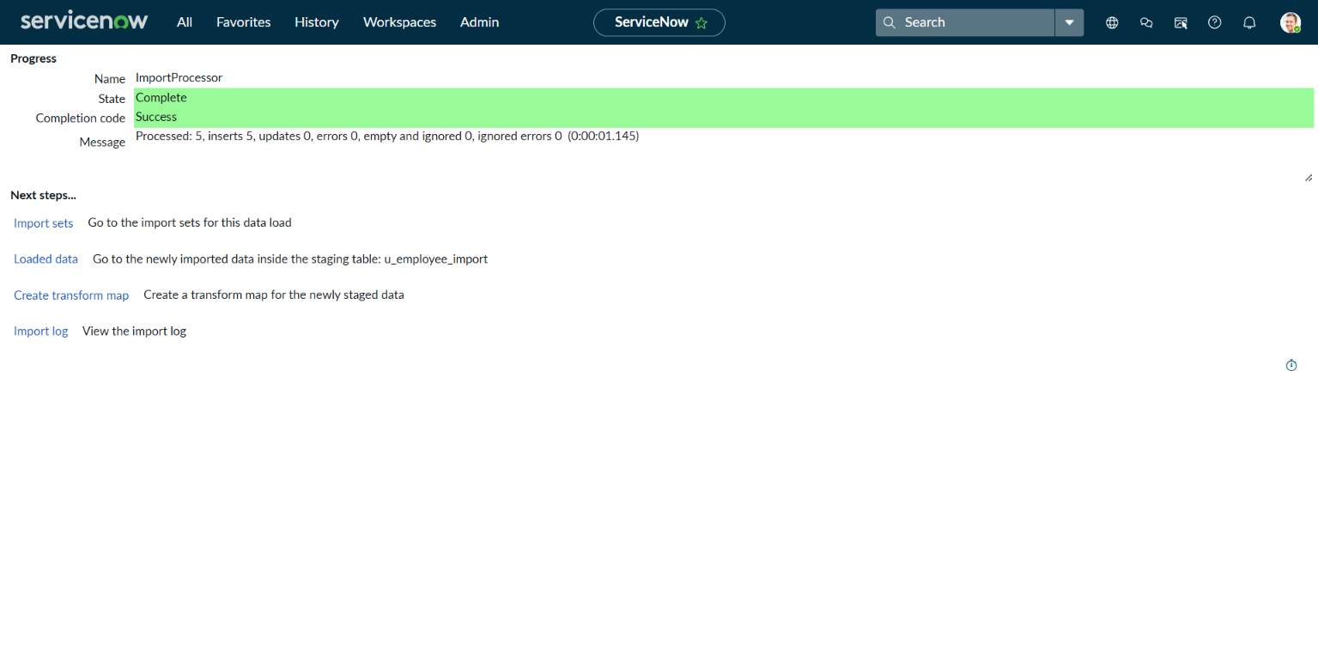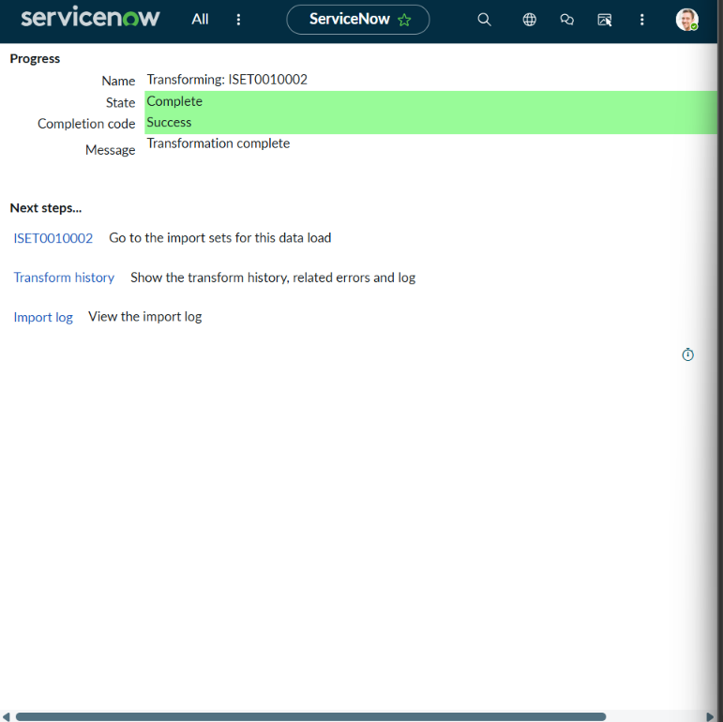
3. | Data Validation (Employee Test table) | After the transform, the Employee Test table shows all 5 records (1 to 5 of 5) with Employee ID, Employee Name, Department, Email and Location (SB0001 to SB0005).  After the next import with a new row (SB0006), the table shows 6 records (1 to 6 of 6); SB0001 to SB0005 each appear only once, so no duplicate records were created. | 